How to index fjson data into SOLR?

<https://www.youtube.com/playlist?list=PLJbE6j2EG1pZ7YfU05bCqdv5bDkKo75nQ>

* Need to install cURL

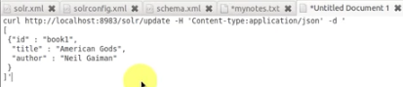

1. Start SOLR/Blacklight through cmd
2. Make sure records are structured in JSON format and that each one has an id field
3. Send a command through cURL to /solr/update with the json file to index.
4. (Optional) Check /solr/get?id=book1 and it should response w/the json file.

How to index locally hosted json files?

* <https://wiki.apache.org/solr/UpdateJSON>
* curl 'http://localhost:8983/solr/update/json?commit=true' --data-binary @books.json -H 'Content-type:application/json'

How to configure?

* solrconfig.xml